Java 8: Optional

<https://www.youtube.com/watch?v=Ej0sss6cq14>

Only for return types:

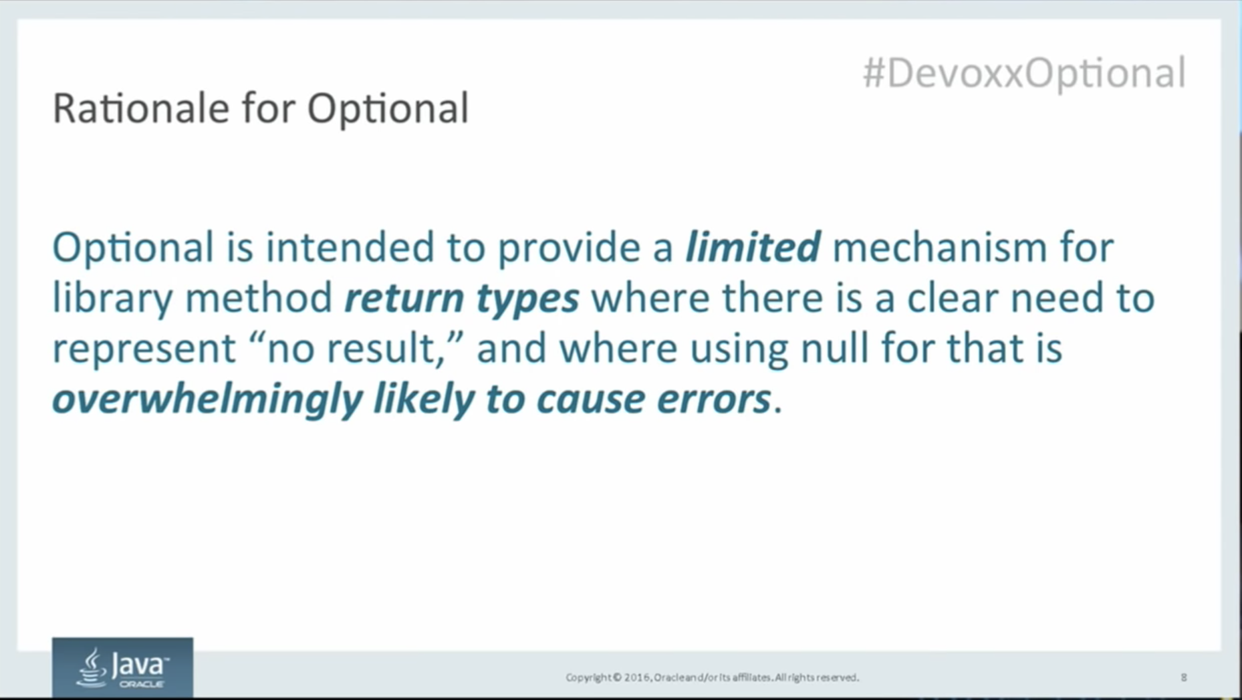

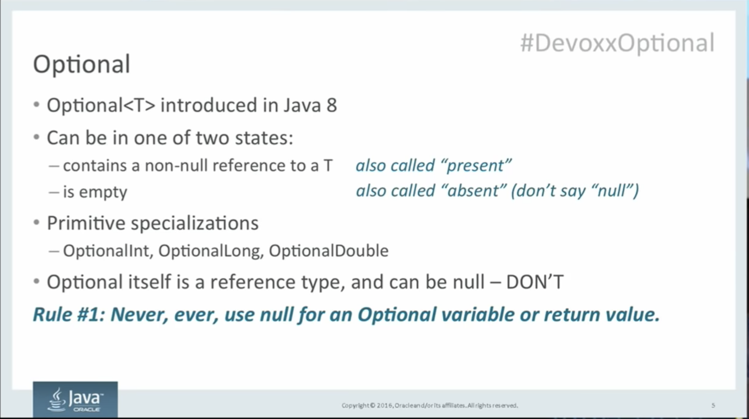

Rule3:

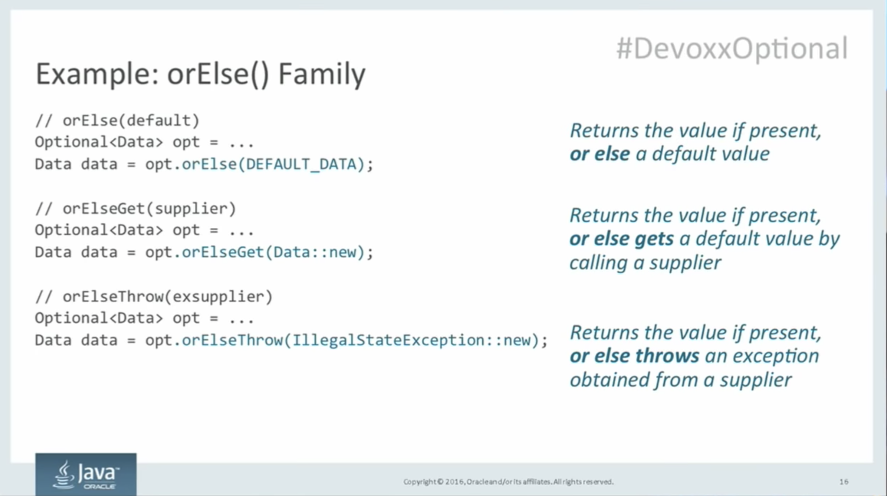

map and orElse can be used along with streams as well.

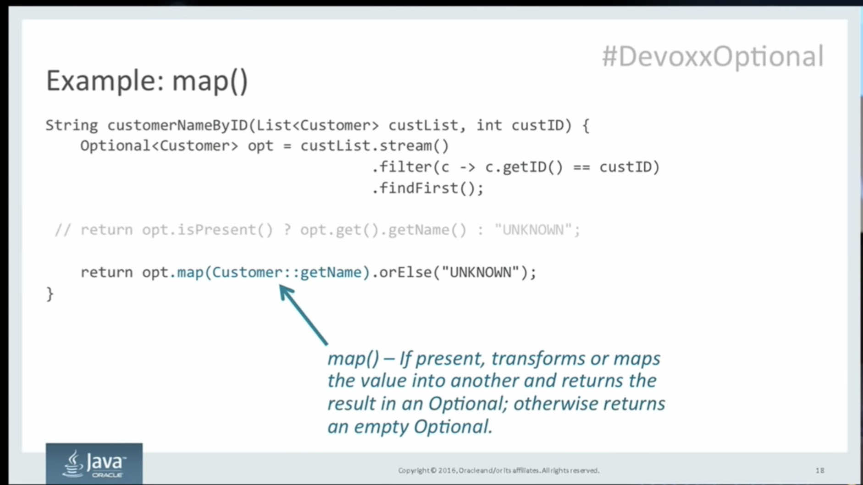

Filter: to apply some predicate

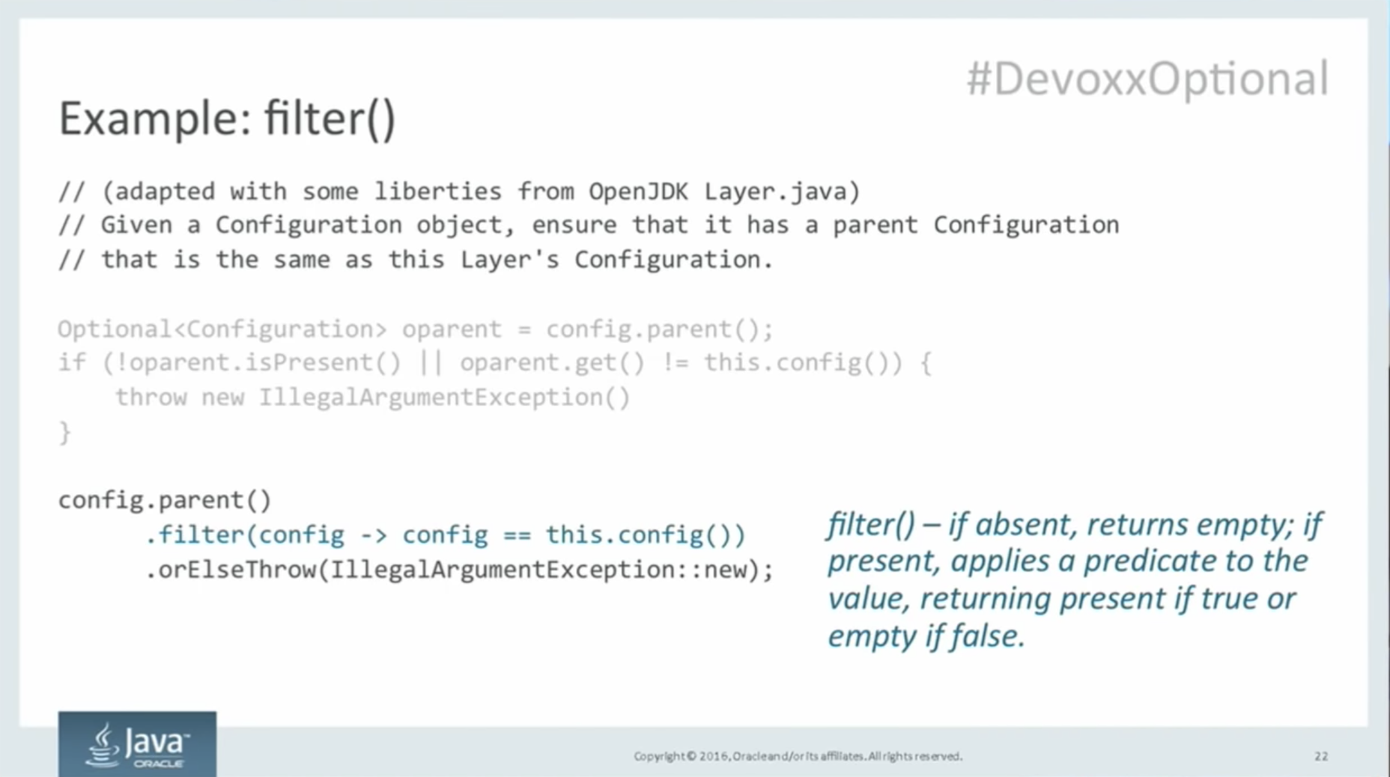

ifPresent()

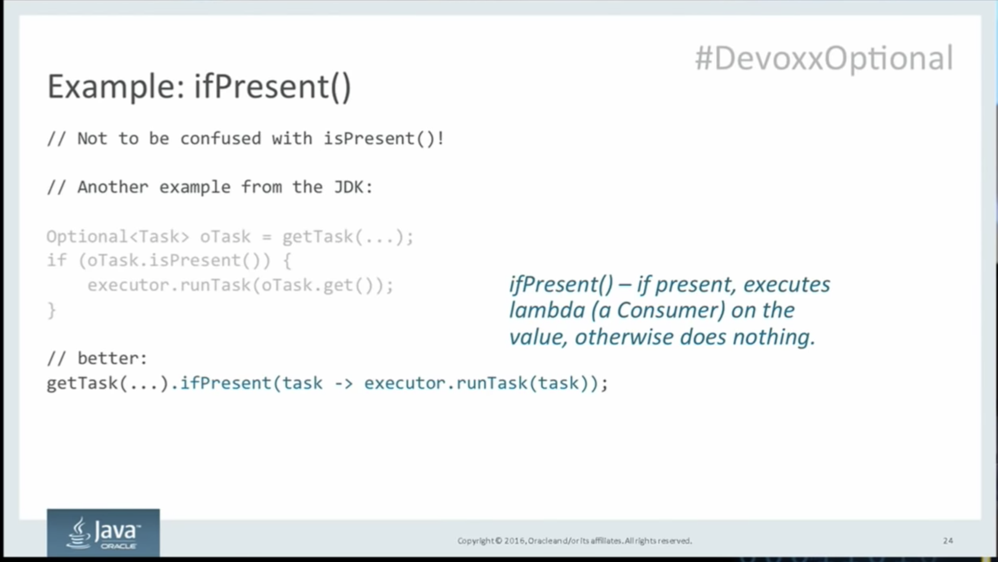

Optional doesn’t have constructor only static methods:

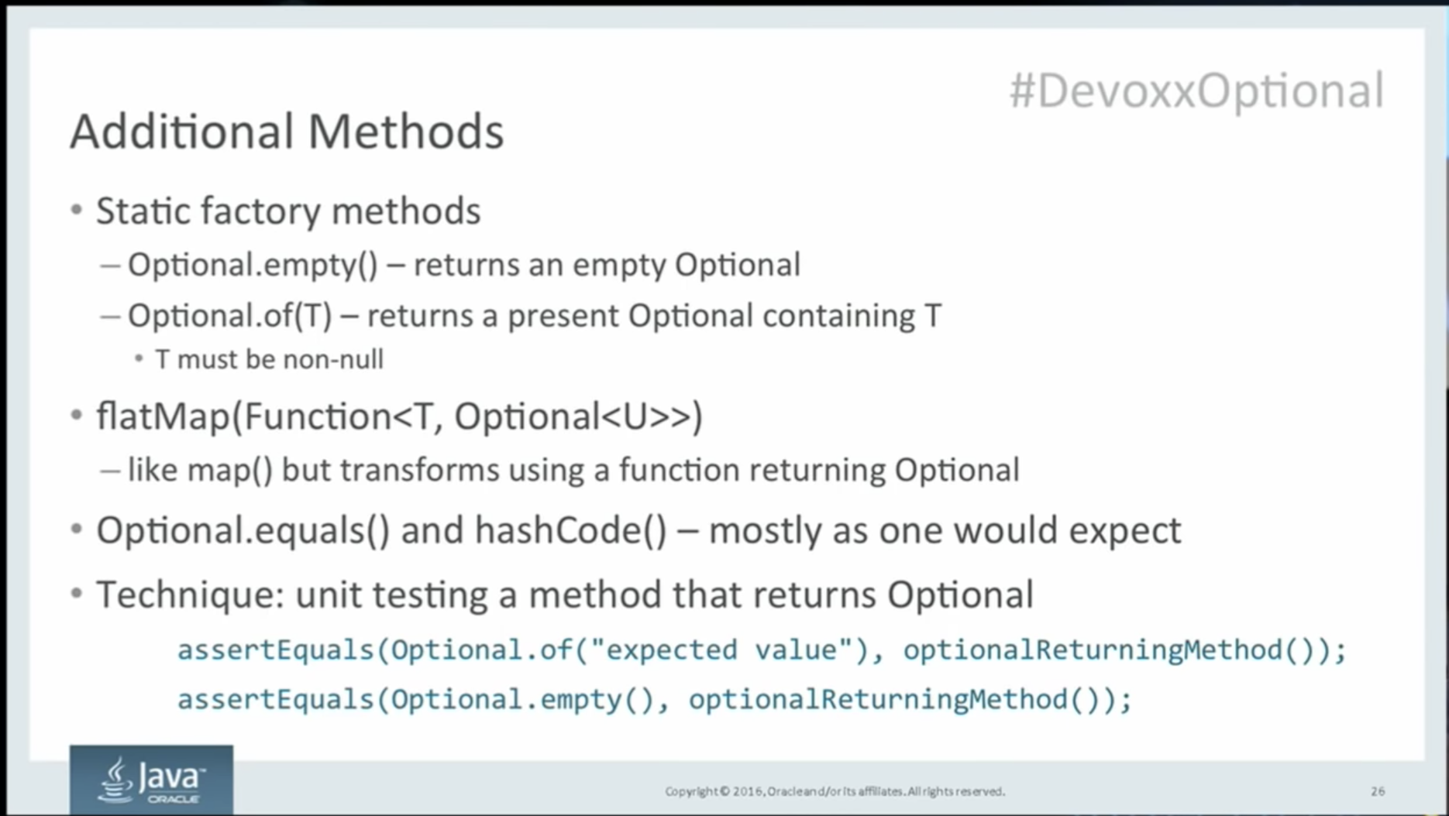

**ofNullale is like of method except it accepts nullable value.**

